**Service Line Inventory Notice**

11/5/2024

Dear City of Toccoa Water Customers,

The Safe Drinking Water Act and the EPA Lead and Copper Rule Revisions require every community water system to create a Service Line Inventory, where the water system will identify every water service line in its system and identify the pipe material of the public and private-side service line. We at the City of Toccoa would like to tell you what actions we are taking to protect public health and continue to provide safe, quality drinking water to the citizens of Toccoa and Stephens County. We are sure you will have questions, so we have provided answers to anticipated questions below. Should any other questions arise, please feel free to contact us at *[hscott@cityoftoccoa.com](mailto:hscott@cityoftoccoa.com)* or at (706) 886-8451.

**What are the Lead and Copper Rule Revisions?**

In 2021, the EPA revised the 1991 Lead and Copper Rule to strengthen the existing regulations and improve public health protections by focusing on identifying and removing **lead service lines**. As part of these Lead and Copper Rule Revisions (LCRR), the City is required to create a publicly available **service line inventory**, which identifies the pipe material of the public and private-side service line. The ultimate goal is to remove lead service lines that can contribute to lead contamination in drinking water. Other changes to the rule include revised tap sampling protocols, required testing for schools and daycares, and public education procedures.

**What is a Service Line?**

A service line is the piping that runs from the water main to the building inlet. Ownership varies by water system but is typically split between the water system and the property owner. The City of Toccoa owns the section of the service line from the water main to the meter box, while the section from the meter box to the building is owned by the property owner.

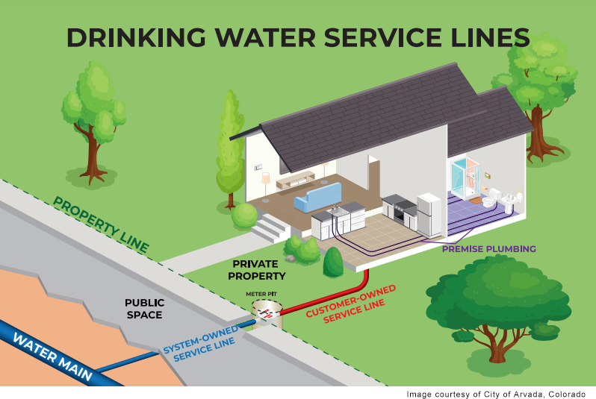

**How Can Lead Enter Your Drinking Water?**

It is important to know that **lead does not naturally occur in drinking water sources**, and the treated water that leaves the City of Toccoa Water Treatment Plant does **not contain lead or copper**. Lead and Copper can infiltrate into drinking water through the corrosion of lead piping, fittings, or plumbing appurtenances, including service lines and interior plumbing. The City of Toccoa performs routine testing for lead and copper contamination at points-of-use, and the City has **never had a lead or copper violation** since the inception of the Lead and Copper Rule.

**What Can I Do to Protect Myself from Lead and Copper Contamination?**

Rest assured that the City of Toccoa is taking action to ensure lead and copper exposure is not prevalent in drinking water supplied to the City and to Stephens County. It is important to know that lead and copper exposure is a rare occurrence. The City has routinely **met or exceeded federal standards** for lead and copper in drinking water, and after physically verifying almost 4,000 service lines to-date, **zero lead service lines were found**.

If you are concerned about exposure to lead in drinking water, please visit EPA’s website at <http://www.epa.gov/lead> or contact your health provider for ways to identify or reduce lead exposure.

**What is the City of Toccoa Doing to Prevent Lead and Copper Contamination?**

The City of Toccoa public works staff have been working hard to identify the pipe material of the service lines in the drinking water system. Service lines are divided into four classifications: **Non-Lead, Lead, Galvanized-Requiring-Replacement**, and **Unknown**.

* **Non-Lead** service lines are determined to be non-lead-bearing material through either an evidence-based method or through visual verification.
* **Lead** service lines partially or completely consist of lead pipes. The City has not found any lead service lines to-date.
* **Galvanized-Requiring-Replacement** services lines are made of galvanized iron or steel. It is possible for galvanized iron or steel pipes to “hold on” to lead particles in drinking water if lead piping existed upstream of the galvanized pipe. Out of an abundance of caution, galvanized service lines are scheduled for replacement if it cannot be determined that the service line was never downstream of lead piping.
* **Unknown** service lines have not been identified by the City, yet.

The City of Toccoa will soon mail out **Service Line Notification Letters** to inform you which service line classification your service line belongs to, according to the initial service line investigation. **If your service line is determined to be non-lead, you will not receive a letter**. The notification letters will also inform you how to access the results of the initial service line investigation, where you can view all the service line inventory information online.

As always, the safety and well-being of the citizens of Toccoa and Stephens County are our top priority. If you have any questions or concerns, please contact us at [*hscott@cityoftoccoa.com*](mailto:hscott@cityoftoccoa.com) or at (706) 886-8451. For more information on lead and copper in drinking water and the Lead and Copper Rule, please see the list of resources below.

Sincerely,

City of Toccoa

92 North Alexander St

Toccoa, GA 30577

Resources

* <http://www.epa.gov/lead>
* <https://www.epa.gov/ground-water-and-drinking-water/basic-information-about-lead-drinking-water>
* <https://www.epa.gov/ground-water-and-drinking-water/revised-lead-and-copper-rule>
* <https://www.epa.gov/ground-water-and-drinking-water/proposed-lead-and-copper-rule-improvements>
* <https://www.cityoftoccoa.com/utilities/page/water>